Project Motivation/Objectives

The proposal of the Project is to upgrade the Infrastructure of the Information & Link Network (ILN) of the Menoufiya University and its branches distributed at Shebin El-Kom City, Menouf City, Ashemon City and El-Sadat City, Menoufiya Government.
The following Figure 1 illustrates the complete configuration of the Information & Link Network (ILN) of the Menoufiya University and its branches, which will be the same except the replacement of the equipments which anticipated the increase in Internet B.W., also the connection of the new branches with the same topology of the hole network.

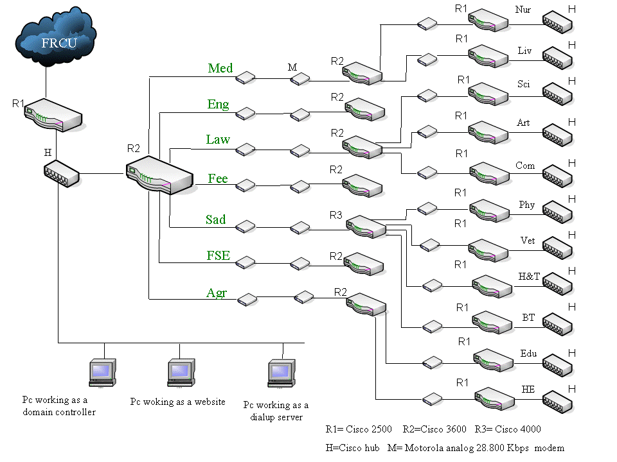

Figure 1 The complete configuration of the Information & Link Network (ILN) of the Menoufiya University and its branches.

However, there are new Faculties, Institutes, and Centers have been established and are not yet connect to the Internet, therefore it should be considered with the upgrade of the Infrastructure Enhancement of Menoufiya University. The activities of the project are to help the Information & Link Network to establish a robust, standards based infrastructure, including hardware ( powerful Routers, Switches (core, modular, edge, shared switches), Hubs, Modems, Servers, Firewalls, PCs, …etc.), software (latest databases, and web developers software) associated applications, extra, intra, and inter Network Connectivity, and global connectivity through the Internet. Deployment of a high-speed network infrastructure based on international standards at each node of the hole network. The main network principle will be high speed ATM or Gigabit backbone ( E3---------->Gigabit ), modular switches at each faculty, institute, center levels, edge switches at the departments & laboratories level, and shared switches at the libraries and faculty office level.

Finally the main principles of the project are :

- To enhance and upgrade the infrastructure of the ILN and its branches.
- Simultaneously upgrade the bandwidth of the connectivity between the ILN and FRCU ( E3---->Gigabit ).
- Upgrade the extra, intra, and intra links between the ILN and its branches at Shebin El-Kom, Ashemon, Menouf, and Sadat City.
- Connect the Internet to the new faculties, institutes, and centers which are not yet have accessing to the Internet.
- Guarantee to support newly instruments, and services based on the e-technologies.
- Provide security policy and mechanisms to protect the Information Technologies resources of hole ILN and its branches.
- Provide good helps, best services, and guidelines for the end users.

